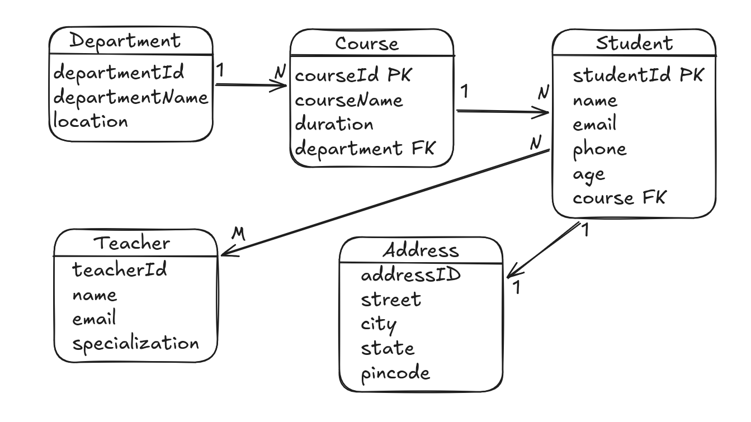

Operations to Perform — College Management System

1. Department
- Add department
- Update department
- Delete department
- Find department by ID
- Display all departments
- Find all courses in a department

2. Course
- Add course to a department
- Update course
- Delete course
- Find course by ID
- Display all courses
- Find course's department
- Find all students in a course

3. Student
- Add student to a course
- Update student
- Delete student
- Find student by ID
- Display all students
- Find student's course
- Find student's department
- Find student's address

4. Address
- Add address for student
- Update address
- Delete address
- Find address by student

5. Teacher
- Add teacher
- Update teacher
- Delete teacher
- Find teacher by ID
- Display all teachers
- Find all students taught by a teacher

6. Student ↔ Teacher
Many-to-Many operations:
- Assign teacher to student
- Assign multiple teachers to student
- Assign multiple students to teacher
- Remove teacher from student
- Find all teachers of a student
- Find all students of a teacher

7. JPQL Practice
- Find all students in BCA
- Find all courses in Computer Science department
- Find all teachers of Arun
- Find all students taught by Ravi Sir
- Find students from a particular city
- Count students in each course
- Count students taught by each teacher
- Find students whose age is above 20

